

**TABLE OF CONTENTS**

|  |  |
| --- | --- |
| **CONTENTS** | **PAGE NUMBER** |
| Brief decription | 3 |
| Colour section | 4 |
| Typography | 5 |
| Navbar | 8 |
| Wireframe | 9 |

**BRIEF DESCRIPTION**

**This project is basically a content management system with different functionality. This portfolio site is made for the personal purpose.**

**There are some of the services and task which the site provides the user and admin both -:**

Home

Which gives a brief summary of the admin and the site what it is about .This page includes a featured slider and a connected panel which gives the user the links to distinct social networking sites to follow the admin and his realted projects.

About me

This gives user a glimpse about the admin , his objectives , strengths , qualification , and various other co-curricular activities and achievements. It also includes a latest picture of the admin.

Projects

In this page admin posts his recent work done in various fields . The user also have a chance to look on the projects of the admin and their respective reports assigned to it in a new tab .

Services

It reveals the offer and services which the site gives to its user . The services are java programming, web designing ans software testing.

Contact me

All the contact details of the admin are given on this page like contact number , work phone, and email id .Moreover this page also contains the connected pannel same as that on the home page, so that the user can follow the admin.

**Purpose**-:The main purpose of this project is that the admin can pay attention on his work easily through this project. And anyone can use my website and retrieve the information about his projects.

**COLOUR SECTION**

|  |  |
| --- | --- |
| **HEXADECIMAL VALUES** | **DESCRIPTION** |
| #B45F04 | Background colour of active page |
| #FAAC58 | Border colour |
| #61210B | Background colour of nav bar |
| #FFFFFF | White |
| &#x2039 | Left arrow |
| &#x203a | Right arrow |
| &#169 | Copyright symbol |

**TYPOGRAPHY**

H1 tag with font style oblique

Logo with a height of 150px and aligned left

Nav bar

H2 tag aligned left

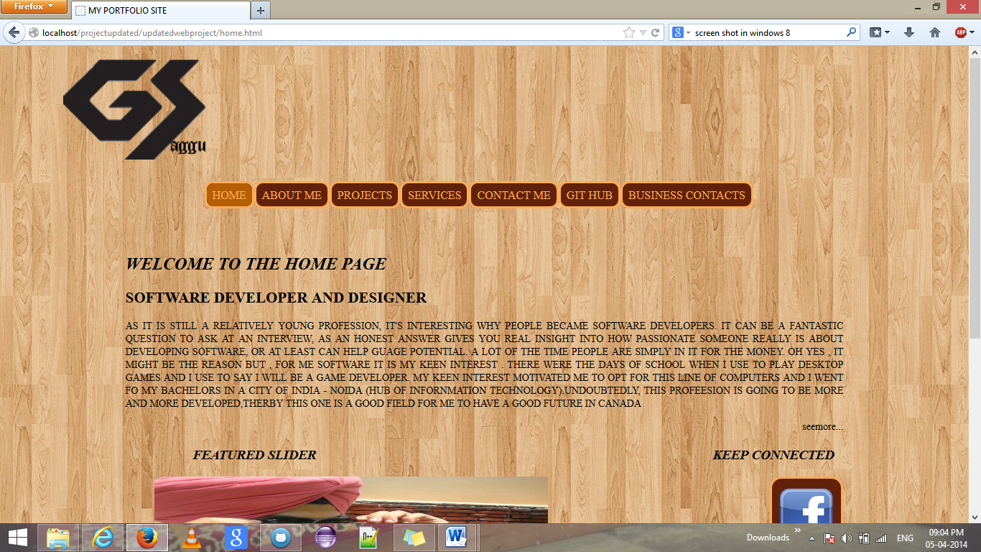

Action button aligned right

A div tag “mission” with font size 14px and alignment is justify

H3 tag with font style oblique

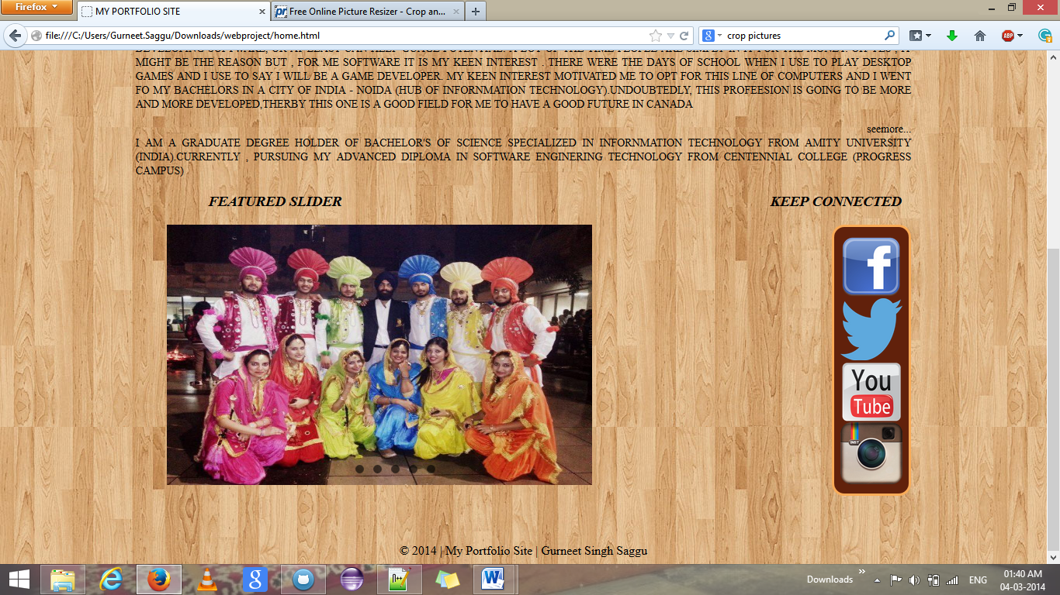

Images on slider with their links

A div tag “connect”

Footer tag aligned centre and with top margin 80px

Images in “connect” with their respective links

Radio buttons on slider

Images on slider with dimension of 90 by 80 and their respective links

a class “nav label” with dimension 150px by 340px

Symbol used for viewing next image with font size 50px and aligned center

Radio buttons on slider

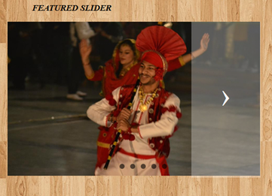

Border colour and with radius 16px

Images with a perfect dimension of 80px by 80px

A div connect with height 320 and a background colour



**NAV BAR**

Border 3px solid and 12px radius

Border colour #FAAC58;



background colour #61210B

Font colour #FAAC58 and display block

background colour changed to #B45F04

Navbar is created with a <ul> tag with id “navbar” under which different names are assigned to their respective pages using a < href tag.This nav bar is under a HEADER section which has margin at left and right by 20%.The ul tag is list style is set to none ,so that to get rid off the bullents created by <ul> tag.Each <li> tag under <ul> tag is assigned with a border , border radius , border colour , background colour and with a specified height and width .Every text in <li> tag is aligned centre. However,the <a> tag under each <li> tag have a padding property, font colour, text- decoration is set to none to get rid off the underline link and is display in a block.

At home page , <a> tag is assigned with an id so that we can specify that we are on home page,therby using css I override the background colour for the <a> tag of home page. Similarly each page’s <a> tag is assigned an id on their respective html code and background colour is changed when that id call the properties from css file.Therefore ,when ever a user is working on particular page the the background of that specific link changes its background colour.

**WIREFRAME**

**Wireframe for business contacts login form**

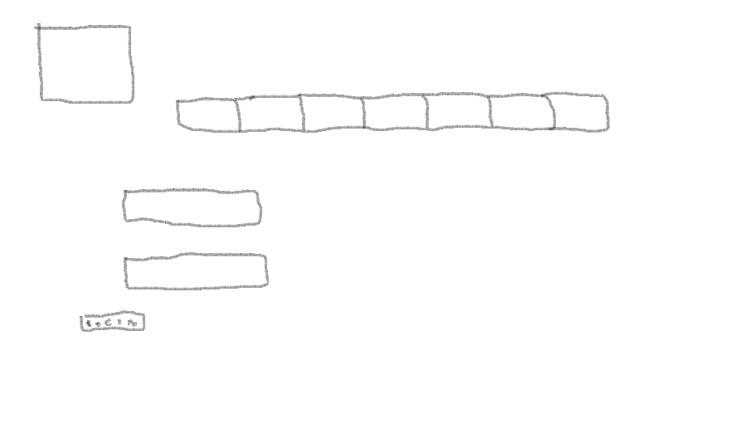

**Wireframe for business contacts page which includes different businees contacts of admin**

Nav bar

Logout link to login form

Image from database

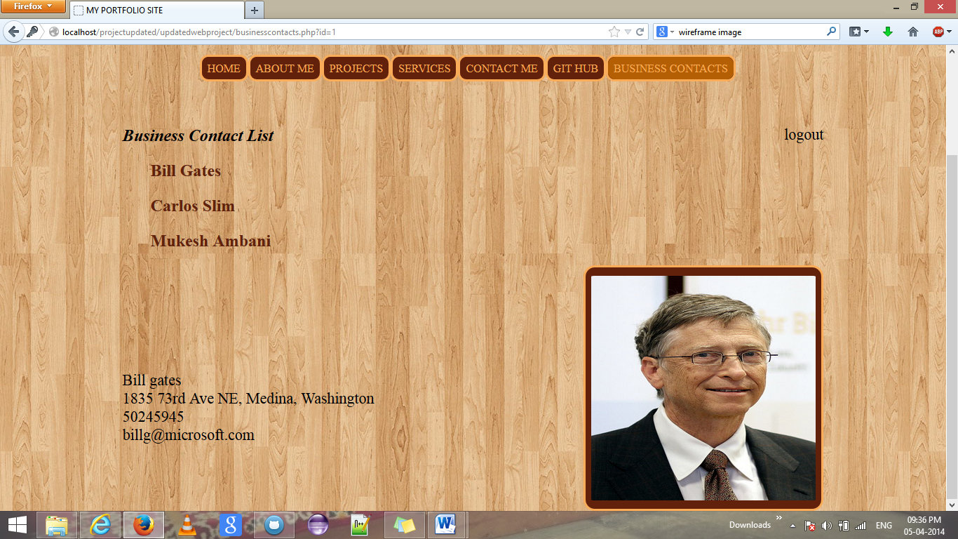

A div tag displaying information from database